MANGOCHI CATHOLIC DIOCESE MOCK EXAMINATIONS

2025 MALAWI SCHOOL CERTIFICATE OF EDUCATION
AGRICULTURE
Subject Number: M012/1
Monday, 12 May 2025 Time Allowed: 2 hrs
8:00 - 10:00 am
Question Number | Tick if answered | Do not write in these columns
Total
PAPER I
(100 marks)

Instructions
- This paper contains 8 printed pages. Please check.
- This paper has two sections A and B
- Answer all questions in the spaces provided.
- Write your Examination Number on all pages
- At the end of the examination, hand in your paper to the invigilator.

© 2025 MH DIOCESE Turn Over
Section A (70 marks)
Answer all questions in this section in the spaces provided
1 (a) State any two ways in which controlling stocking rates in pastures is important.
__________________________________________________________________________________________________________________________________________________ (2 marks)
(b). Explain any two disadvantages of broadcasting method for sowing pasture seeds.
___________________________________________________________________________________________________________________________________________________ (2 marks)
2 (a). Describe any two bad farming practices which destroy soil structure.
___________________________________________________________________________________________________________________________________________________________________________________________________________________________________________________________________________________________________________________________________________________________________________________________________________________________________________________________________________ (4 marks)
(b) .Explain any two importance of performing the following practice in Livestock production.
- Steaming up
________________________________________________________________________________________________________________________________________________________________________________________________________________________ (2marks)
- Castration
________________________________________________________________________________________________________________________________________________________________________________________________________________________ (2 marks)
3 (a) Define livestock management.
______________________________________________________________________________________________________________________________________________ (1 mark)
(b) Give any two reasons why farmers do artificial insemination in cattle.
___________________________________________________________________________________________________________________________________________________________________________________________________________________________________________________________________________________________________ (2 marks)

(c) .State any two methods of Livestock improvement.
_________________________________________________________________________________________________________________________________________________________________________________________________________________________________ (2marks)
4 (a) State any two ways in which supplying is important in crop production.
_________________________________________________________________________________________________________________________________________________________________________________________________________________________________ (2marks)

Continued/…
(b) Give any two advantages of organic fertilisers in the soil.
________________________________________________________________________________________________________________________________________________________________________________________________________________________________ (2marks)
(c) State any two effects of too much air in silage making.
_________________________________________________________________________________________________________________________________________________________________________________________________________________________________ (2 marks)
Figure 2 below is a flow diagram for biogas production. Use it to answer questions (i) to (iii)
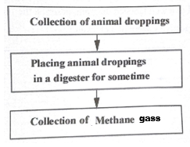
Figure 2
- Name the process that takes place in a digester.
__________________________________________________________ (1 mark)
- Give any one advantage of collecting methane gas.
____________________________________________________________________________________________________________________________ (1 mark)
- Explain any two ways in which the biogas production mitigates climate change.
___________________________________________________________________________________________________________________________________________________________________________________________________________________________________________________________________________________________________________________________________________________________________________________________________ (4 marks)
5. (a) State two symptoms of Mastitis in Livestock Production.
________________________________________________________________________________________________________________________________________________________________________________________________________________________ (2 marks)
(b). Explain any two ways in which use of animal power increases food production in Malawi.
__________________________________________________________________________________________________________________________________________________________________________________________________________________________________________________________________________________________________ (4 marks)
Continued/…
6. (a) Explain any one way in which each of the following farming technologies would improve food security:
- irrigation
_______________________________________________________________________________________________________________________________________________________________________________________________________________________(2 marks)
- pest and disease management
_________________________________________________________________________________________________________________________________________________________________________________________________________________________(2marks)
(b) Explain any two reasons why drought tolerant crops can help in achieving food security.
_________________________________________________________________________________________________________________________________________________________________________________________________________________________(2marks)
7. (a) Give any two ways in which a green house is important in crop production.
________________________________________________________________________________________________________________________________________________________________________________________________________________________ (2marks)

(b). Describe any two effects of population distribution on marketing.
________________________________________________________________________________________________________________________________________________________________________________________________________________________ (2marks)
8. (a) Explain any two ways in which living organisms help to maintain plant nutrients in the soil.
___________________________________________________________________________________________________________________________________________________________________________________________________________________________________________________________________________________________________ (4marks)
(b). State any one way of improving output from each of the following sources of farm power:
(i) Draught animals
______________________________________________________________________(1mark)
(ii) Solar
____________________________________________________________________________________________________________________________________________________ (1mark)
9. (a) Explain any one way in which knowledge of signs of heat in cow is important to a farmer.
___________________________________________________________________________________________________________________________________________________ (2marks)
(b) Name two diseases which cause lameness in sheep.
___________________________________________________________________________________________________________________________________________________ (2 marks)
Continued/…
10. Figure 1 below is a diagram showing the digestive system of a farm animal. Use it to answer questions that follow.

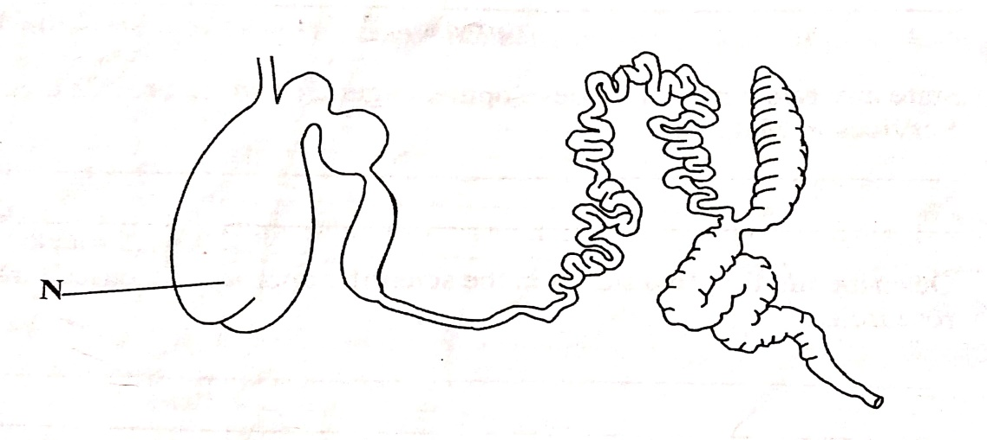
Figure 1
(a). Name the type of farm animals which have the digestive system shown in figure 1.
____________________________________________________________________________________________________________________________________________________ (1mark)
(b). Mention any two nutrients digested in the part labeled N.
___________________________________________________________________________________________________________________________________________________ (2marks)
(c) Explain any one way in which the digestive system is suitable for grass as a feed.
___________________________________________________________________________________________________________________________________________________ (2marks)
11. (a) Outline four steps in silage making.
_______________________________________________________________________________________________________________________________________________________________________________________________________________________________________________________________________________________________________________ (4marks)
(b) Table 1 below shows a type of farm record kept by Mrs. Banda. Use it to answer the questions that follow.
Date | Item | Quantity | Value
12/01/2022 | oxcart | 1 | 70,000
10/02/2023 | land | 4 hectares | 200,000
15/03/2023 | cattle | 3 | 900,000
12/09/2023 | Mango trees | 30 | 40,000

- Name the type of farm record
______________________________________________________________________(1 mark)

Continued/…
(ii). Calculate the value of each mango tree on the farm.

(2 marks)

( c) . Explain any two ways in which agroforestry deals with climate change.
_____________________________________________________________________________________________________________________________________________________________________________________________________________________________________________________________________________________________________________________________________________________________________________________________ (4 marks)
SECTION B (30 marks)
Answer all the three questions in this section
12. The following agricultural development services have just been made available to farmers in a certain area;

- Farm mechanization
- Extension and training
- seed technology
- Agricultural credit
- Irrigation

If the area has for several years experienced the problem of low crop yield, explain any five ways in which the farmers could make use of the services in order to reduce the problem.
_______________________________________________________________________________________________________________________________________________________________________________________________________________________________________________________________________________________________________________________________________________________________________________________________________________________________________________________________________________________________________________________________________________________________________________________________________________________________________________________________________________________________________________________________________________________________________________________________________________________________________________________________________________________________________________________________________________________________________________________________________________
________________________________________________________________________________________________________________________________________________________________________________________________________________________________________________________________________________________________________
Continued/…
________________________________________________________________________________________________________________________________________________________________________________________________________________________________________________________________________________________________________________________________________________________________________________________________________________________________________________________________________________________________________________________________________________________________________________________________________________________________________________________________________________________________________________________________________________________________________________________________________________________________________________________________________________________________________________________________________________________________________________________________________________________________________________________________________________________________________________________________________________________________________________________________________________________________________________________________________________________________________________________________________________________________________________________________________________________________________________________________________________________________________________________________________________________________________________________________________________________________________________________________________________________________________ (10 marks)

13. Explain five factors to consider when mechanizing a farm.
______________________________________________________________________________________________________________________________________________________________________________________________________________________________________________________________________________________________________________________________________________________________________________________________________________________________________________________________________________________________________________________________________________________________________________________________________________________________________________________________________________________________________________________________________________________________________________________________________________________________________________________________________________________________________________________________________________________________________________________________________________________________________________________________________________________________________________________________________________________________________________________________________________________________________________________________________________________________________________________________________________________________________________

Continued/…
_____________________________________________________________________________________________________________________________________________________________________________________________________________________________________________________________________________________________________________________________________________________________________________________________________________________________________________________________________________________________________________________________________________________________________________________________________________ (10 marks)

14. Explain any five advantages of zero grazing system.
_________________________________________________________________________________________________________________________________________________________________________________________________________________________________________________________________________________________________________________________________________________________________________________________________________________________________________________________________________________________________________________________________________________________________________________________________________________________________________________________________________________________________________________________________________________________________________________________________________________________________________________________________________________________________________________________________________________________________________________________________________________________________________________________________________________________________________________________________________________________________________________________________________________________________________________________________________________________________________________________________________________________________________________________________________________________________________________________________________________________________________________________________________________________________________________________________________________________________________________________________________________________________________________________________________________________________________________________________________________________________________________________________________________________________________________________________________(10 marks)

END OF QUESTION PAPER
NB: This paper contains 8 printed pages

